Blueberry, coconut and lime bars recipe
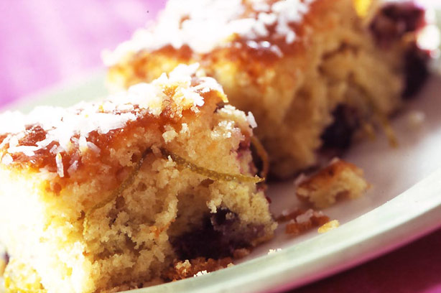

Makes: 16
Nutrition per portion |  | RDA
Calories | 249 kCal | 12%
Fat | 13g | 19%

Fresh blueberries, coconut and lime add something a bit different to these (nearly) healthy bars. Great for lunchboxes, kids’ parties and mid-afternoon snacks!

Ingredients
- 60g desiccated coconut
- 150g punnet fresh blueberries, rinsed
- 40g plain flour
- 175g self-raising flour
- 1tsp baking powder
- 175g caster sugar
- 175g unsalted butter, softened
- 3 medium eggs, beaten
- Grated rind and juice of 2 large limes
- 100g caster sugar

Method
- Preheat the oven to 180C/gas 4. Lightly grease and line a 23cm square baking tin.
- In a small bowl mix together 50g of the coconut, blueberries and plain flour and set aside.
- Sift together the self-raising flour and baking powder into a mixing bowl with the caster sugar, butter and eggs. Whisk together using an electric or manual whisk until the sponge is well blended. Stir in the grated lime and fold in the coconut and blueberry mix. Spoon into the prepared tin and smooth over the surface of the sponge mixture.
- Bake for 30-35 minutes until risen, or when a skewer inserted in the centre of the sponge comes out clean. Remove the sponge from the oven and set aside to cool.
- Whilst the cake is still warm, mix together the lime juice, remaining coconut and caster sugar. Using a skewer prick the sponge all over and drizzle the sweetened lime juice over the surface of the cake. Cut the cake into 15-16 pieces and serve warm or cold.

Top tip for making Blueberry, coconut and lime bars
If blueberries are not available use any soft berry fruits, such as raspberries or blackberries

Taken from www.goodtoknow.co.uk/recipes

