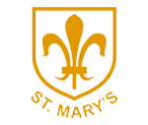
Spring 2 Newsletter

Class 4 | Key Information
Outdoor Learning | We will be making sure the children get plenty of fresh air and a chance to be creative this year by giving each class an additional outdoor learning lesson a week to run along their two PE lessons. This term we will be continuing to go outside on a Friday morning to get creative. Please have wellies, coats and outdoor clothes ready.
PE | PE lessons will again be on Monday's and Wednesday's this term but these are subject to change so please make sure you have your PE kits in school every day. Hoodies and waterproof coats will be needed as we aim to stay outside as much as possible.
Reading Diaries | Please aim to read 5 times a week. Diaries to be in school every day. Books will be changed when completed and checked most days. Children are encouraged to fill in their own diaries in school and at home. One page of the diary should be used for one week of school. Last term’s reading was again a huge success; we thank you for your hard work with this. As well as reading for pleasure please make sure your child is reading the school reading book given regularly in order to progress through the bands quickly. We are working on reading out loud with expression and fluency which is a difficult skill to master.
Coats | Please bring a coat to school as well as your blazers. Please also make sure the coat is labelled with your child’s name.
Uniform | Please remember that a blazer is a compulsory part of the uniform and that your child should wear this at all times unless given permission otherwise. Please make sure all uniform is clearly labelled to avoid any loss.  Wellies and outdoor trainers are crucial too and should be in school everyday.
Homework | Year 6 will receive regular homework in preparation for SATs. It is very important that they complete this each week as it will be used in class time.  TT Rockstars should be completed 5 times a week.  Big Maths sheets will go home on Monday’s and we encourage parents to go through one or two questions with their child each week. Please ask if you need further support on this and the methods we use in school.

Our Curriculum this term...
English  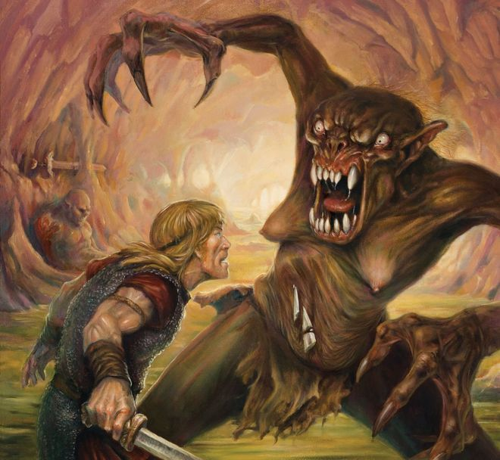 | Our English this term will link to our Vikings Topic. We will be looking at the story of Beowulf and learning to write in different perspectives. During the unit we will also touch upon the story of Odin’s Eye and How To Train Your Dragon. The children will have opportunities to write fiction and non-fiction texts.
Maths | This term in maths the Year 6 children will continue their revision in preparation for SATs. We will be focussing upon ratio, angles, two-step problems and calculating circles.  The Year 5 children will be looking at fractions. Where they will have the chance to compare, convert and calculate them. We will also start to look at the relationship between fractions, decimals and percentages.
History  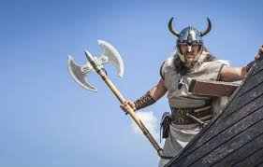 | With an exciting trip to York to help us we will be studying the impact of the Vikings on Britain. Please read through the Vikings information sheet on the Class Blog pages for more information, key vocabulary and ideas to discuss with your child.  https://www.st-marys-colton.staffs.sch.uk/blog/category/class-4
DT | STEM Work with Warwick University. Over the next two terms we will be working with Dr Allen from Warwick University on our STEM project. The children will have the chance to plan, design and make their own eco-car. During this time as well as constructing the car we will also be taking part in some exciting experiments and investigation. Please keep in touch with our Youtube channel in order to keep up to date with our progress.
PE | PE will be Fitness and Basketball this term. In Basketball we will be focussing on the key skills needed, undertaking various drills and skill sessions before playing small games at the end of term. Fitness will focus on developing technique and stamina to perform a range of circuits including the bleep test.
Computing | In Computing we will be Computer Scientists. We will design, write and debug programs that accomplish specific goals and use sequence, selection, and repetition in programs. We will mainly be using Scratch to complete our objectives.  KEY VOCABULARY = ALGORITHM, FLOWCHART,
Religious Education | Salvation; What difference does the resurrection make to Christians?  This unit we will be looking at Salvation. Initially we will learn about the events that led to Jesus being put onto the cross. To help us do this we will be studying the Gospels of Matthew, Mark, Luke and John- finding the details that explain these events. During the unit we will be exploring how Christians believe that Jesus brought man-kind from the dark into the light.
Science | We will be studying the topic of Electricity. This will build on children’s prior knowledge of circuits to help design, plan and establish fair testing. Please see the Knowledge mats within the Blog section of our Class pages for more details. https://www.st-marys-colton.staffs.sch.uk/blog/category/class-4  KEY VOCABULARY  DEPENDENT VARIABLES, PREDICTION, CONCLUSION, METHOD, INDEPENDENT VARIABLES, CELL, CIRCUIT

